***EQUIFAX***

CMS Fusion

**JOB STACKING**

**DOCUMENTATION**

Table of Contents

**Job Stacking1**

New Stack Process2

Stack6

# Job Stacking

The Job Stacking is the concept where we setup different processes [like, input, source match, data menu, refinement, data processing etc.] and put them together and submit as a single job, so that it can be executed one after another in a sequential order.

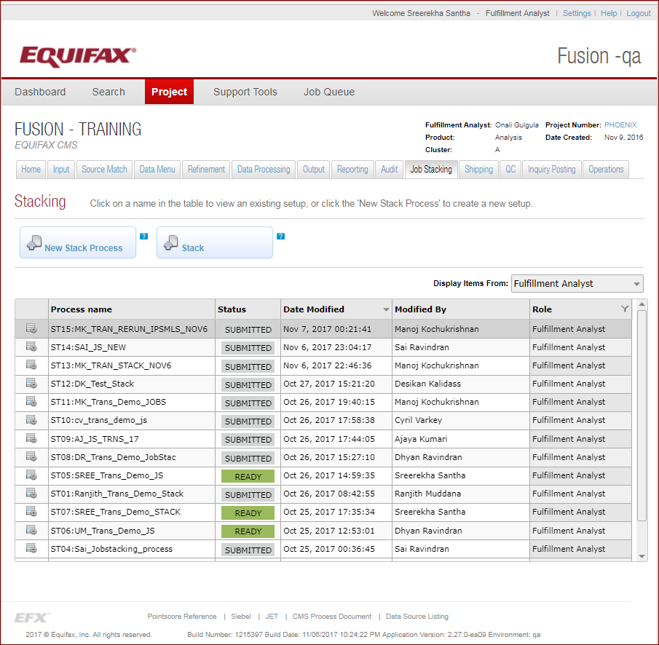

1. **New Stack Process**



New stack process will provide the interface to create a new job stack

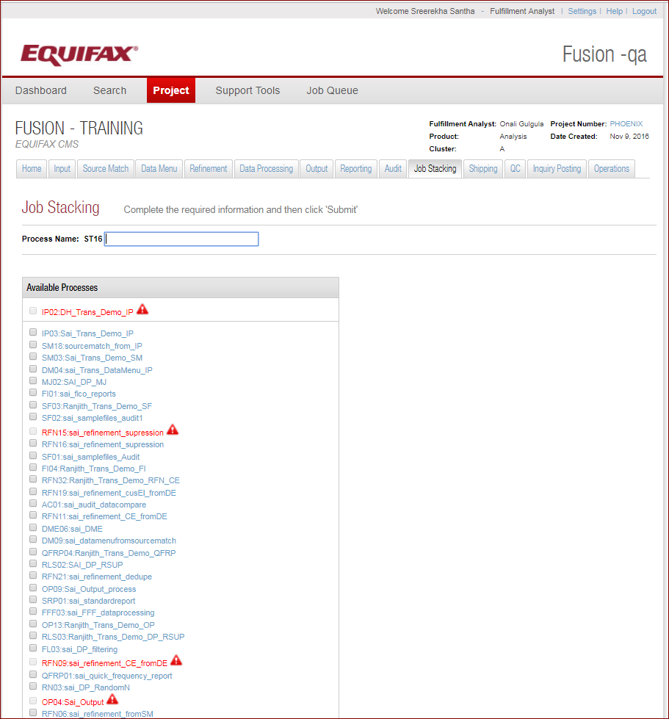

* **Process Name**



The **Process name** is divided into 2 main parts. The first part of the process name is assigned by the system and the second part is entered by the user. The first part consists of a constant “**ST**” followed by a two-byte sequence number beginning with 01 and increasing incrementally by 1 with each new process created.

* **Available Process**

Available Process section lists all process available in the system for the current project which is ready for stacking. It divides process in to dependency thread and grouped in between the green lines and all those processes are dependent on each other. The grouping logic is done by the fusion system.

The process which are in red, are the processes which has errors and cannot be resubmitted or stacked again. The checkbox against such process is not selectable



The processes which needs to be stacked together [from the same hierarchy] needs to be selected and submitted to run

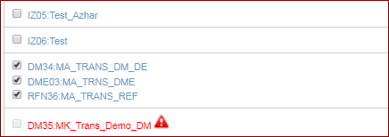

There is a job level validation present which will check whether all the associated processes which are dependent together are stacked together. Otherwise some kind of validation error like below will be shown while submitting



* **Process Summary**

When we click on the process name, a process summary pop up shows the summary of the process

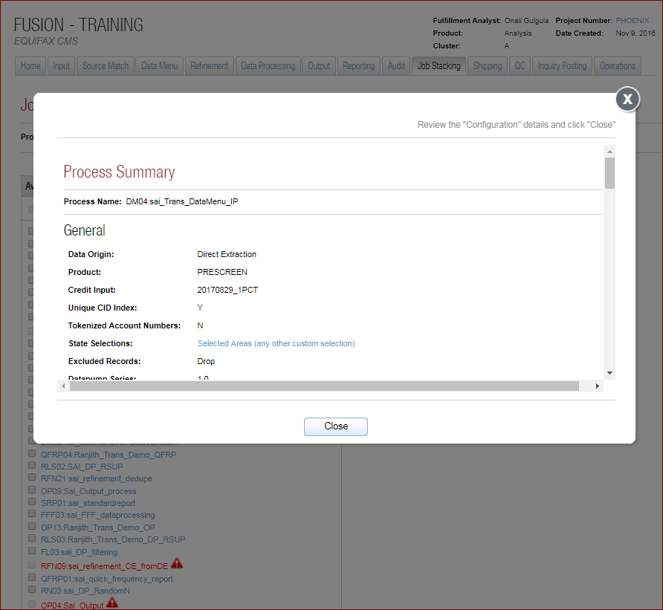

* **Job Dashboard**

Job stack is a single job which contains multiple steps and for each step contains multiple processes and each process contains the multiple work items. Once the Job Stack is submitted, the project dashboard shows the details as below.

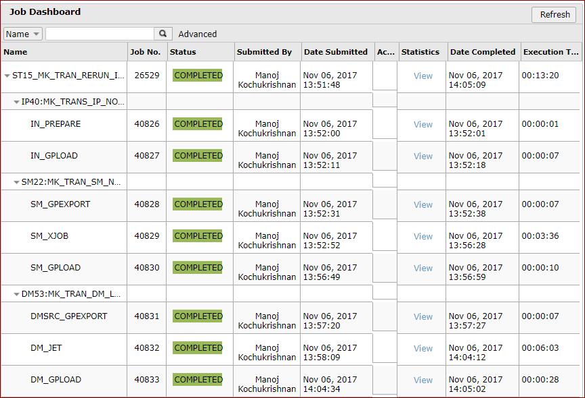

1. **Stack**



It’s Stack Flow Chart and creates the Job Stack from the flow chart. It will show the pictorial view of the flow. All the grouped processes are listed in the Build the Stack drop down. Once the process group is selected a pictorial view of the process flow is displayed as a flow chart, user can select the individual jobs to be submitted together and create the Job Stack and submit. But since it is not very user friendly this functionality is not used.

